MANAGING SLIPS, TRIPS AND FALLS
Slips, trips and falls result in thousands of injuries every year. The most common ones are musculoskeletal injuries, cuts, bruises, fractures and dislocations but, more serious injuries can also occur.
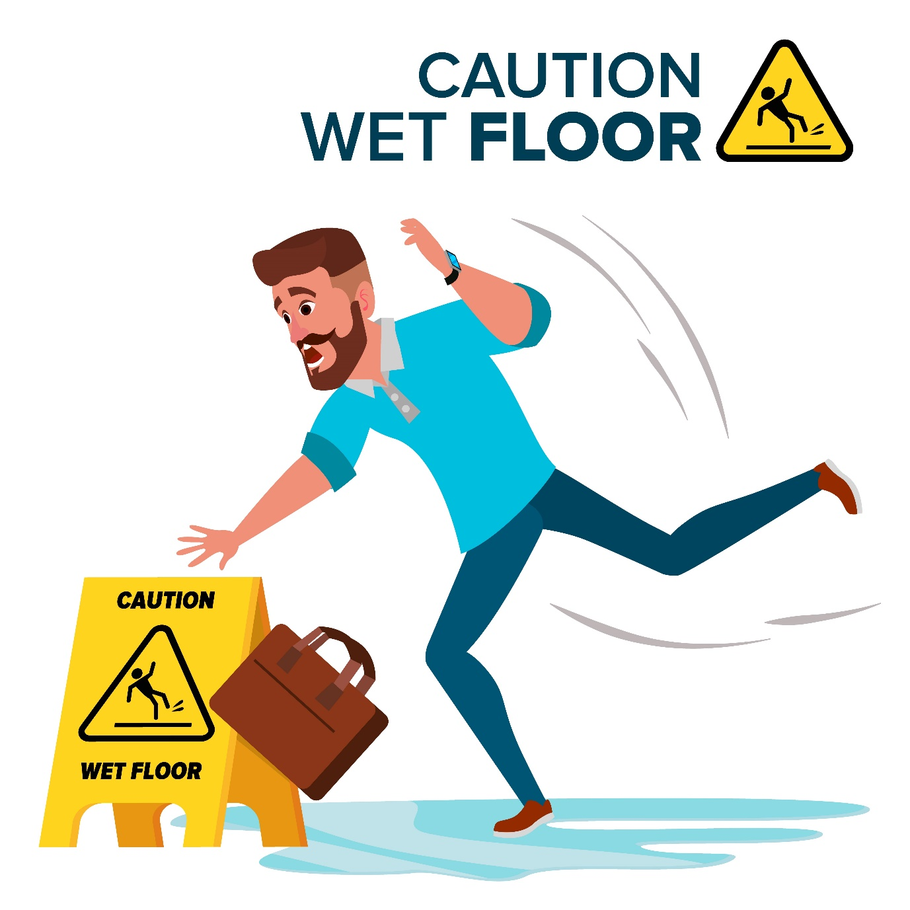
There are various ways to control the risk of slips and trips, some examples are listed below in order of their effectiveness (known as the hierarchy of controls):
Hierarchy of Control | Examples
Eliminate the hazard | Remove slip and trip hazards at the design stage such as eliminating changes in floor levels and installing more power outlets to avoid trailing cords.
Substitution | Replace flooring with a more slip-resistant surface.
Isolation | Prevent access to high risk areas, for example cordon off wet floor areas while cleaning is in progress.
Engineering controls (redesign) | - Apply floor treatments to increase slip resistance  - Improve lighting  - Stop leaks from equipment or pipes  - Provide adequate drainage  - Clearly mark edges of steps and any changes in floor height.
Administrative controls | - Implement good housekeeping practices including keeping access ways clear and cleaning up spills immediately  - Use signage to warn of wet or slippery areas  - Provide training and supervision.
Personal protective equipment | Wear slip-resistant footwear.

